## SAMPLE COLLECTION

|  |  |
| --- | --- |
| User Name: ……………………………………………. | Trainer Name: Ruchira Ariyasinghe |
| User Sign. : ……………………………………………. | Trainer Sign. : ……………………………………………. |

##### SAMPLE COLLECTION

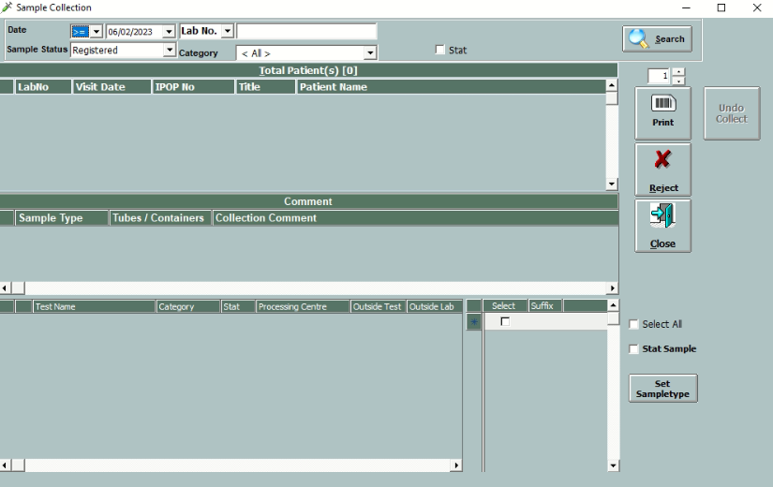

* This is sample collection window.
* Once subject is registered it will be available in sample collection window. Without sample collection it will not allow the tests for sample acceptance.
* It will generate barcode according to number of departments.
* To reprint barcode, select sample status as “SAMPLE COLLECTED” and then click on LOAD button.
* User can reject the sample by using “REJECT” button. This test will be known as “REJECTED” test. Rejection can be done by user by putting appropriate reason. (E.g. Sample Haemolysed, Sample not sufficient etc.) Rejection details can be entered in the ‘Comment’ field.

